AUSAM (v2) Instructions

1. Log into ADS
2. Click the button marked “Print” under the “Annual Update” section

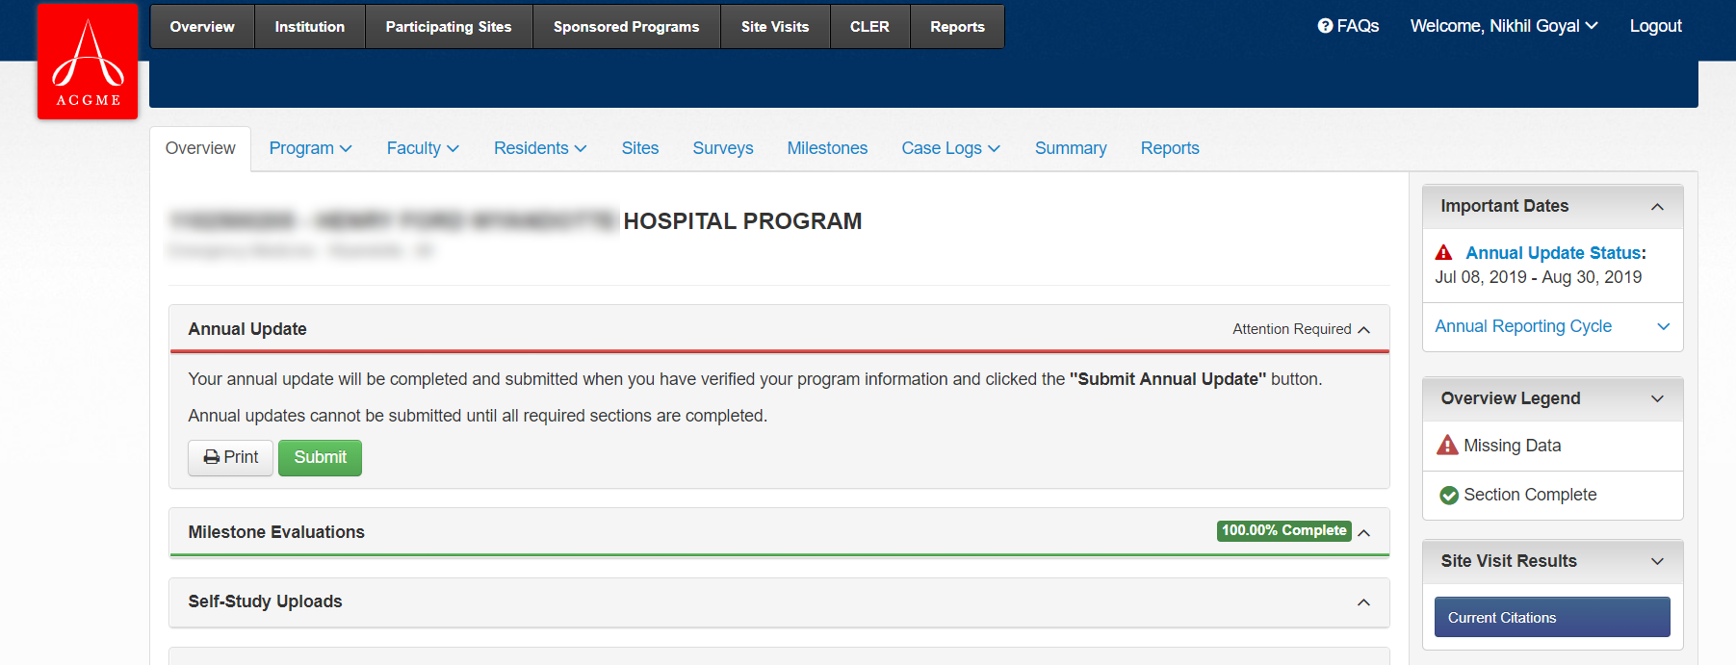

1. Wait for a new window to appear
2. Hold down the **Ctrl** key and press and release the letters **U, A, C** in sequence (Safari: Option+Command+U, then Command+A, Command+C)
   * This will display the page in HTML format, highlight all the code and copy it to the clipboard
   * Nothing may appear to happen after you press the C key

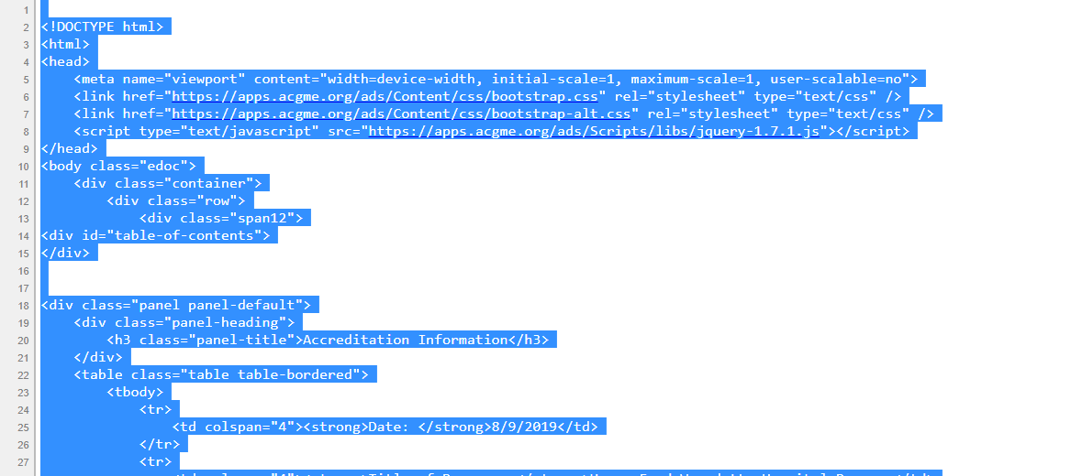

1. In your internet browser, browse to [**https://ausam.meded.app**](https://ausam.meded.app)
2. Click inside the large text box that says “Paste block of text from ADS”
3. Press **Ctrl-V**. The code from the ADS summary page will appear in the box

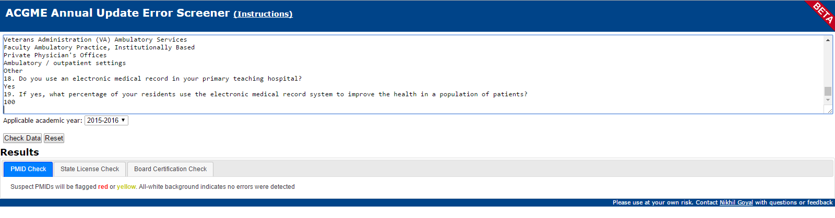

1. Set the “applicable academic year” using the dropdown box
2. Click “Check Data”